**Week 4 Assignment**

**Database Development and Class Registration**

John Home

The University of Arizona Global Campus

CST 499: Capstone for Computer Software Technology

Dr. Charmelia Butler

7/3/2023

Going through the implementation phase for this website was fun and had its challenges. I built a class to connect to the database so I did not have to constantly code it into each sheet. For finishing the website I created a table to store what classes a student had signed up for so it could be tracked. I wanted to be able to show different information on the landing page and registration page based on the actions of the user. For the landing page I spent a lot of time working out how to show the classes the user was registered for only if they were actually registered for classes. If they are not registered they will only get prompted to register. On the registration page I created a form with a drop down menu of the different semesters that could be selected. The information from the drop down was then cycled through the page when the user hits select. This triggers a MySQL query to pull the classes that are available for that semester and present the options to the student. Once they identify what class they would like to take they can then add the classID to the selection box and hit submit and it will register them to that class in the database. A successful registration will display a message stating what class they signed up for and give them an option to register for another class or they can select an option from the header to perform a different action. When the user returns to the home page they will not see a table with the classes they have registered for and have the option to remove a class.

The biggest challenges were getting the pages to display the information I wanted only when it was appropriate. I did not want a box sitting on the home page to drop a class if the student was not registered for any classes. I also did not want any classes displayed on the registration page if there was not a semester selected.

**Images and Code**

**Landing page with no registered classes**

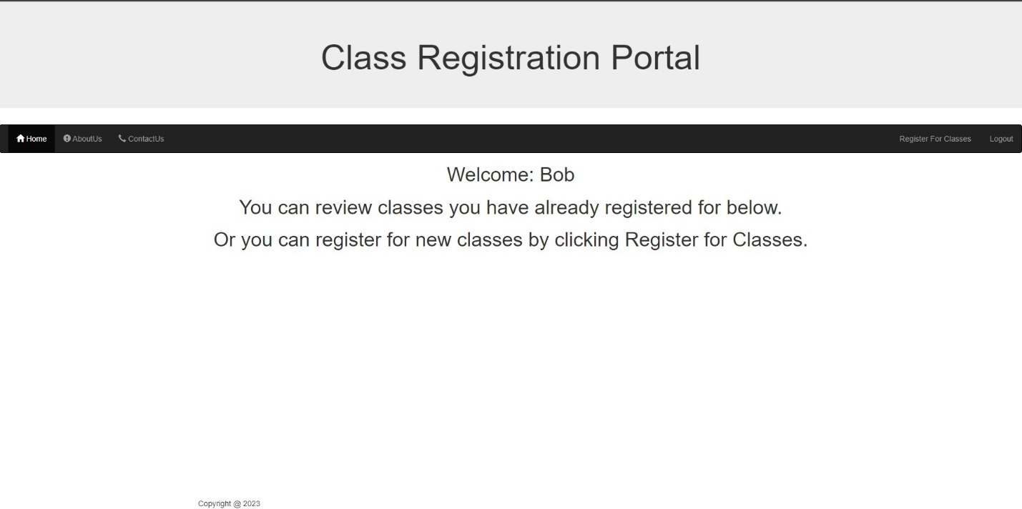

**Landing page with registered classes**

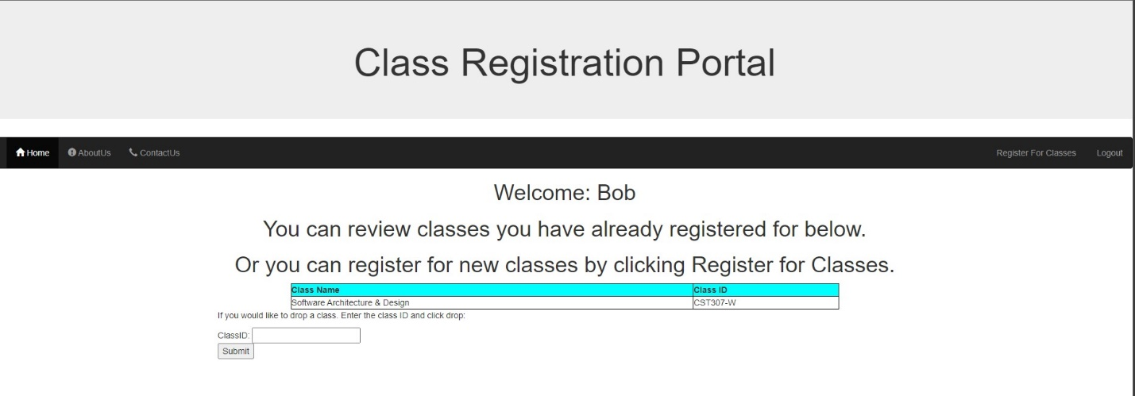

**Landing Page php**

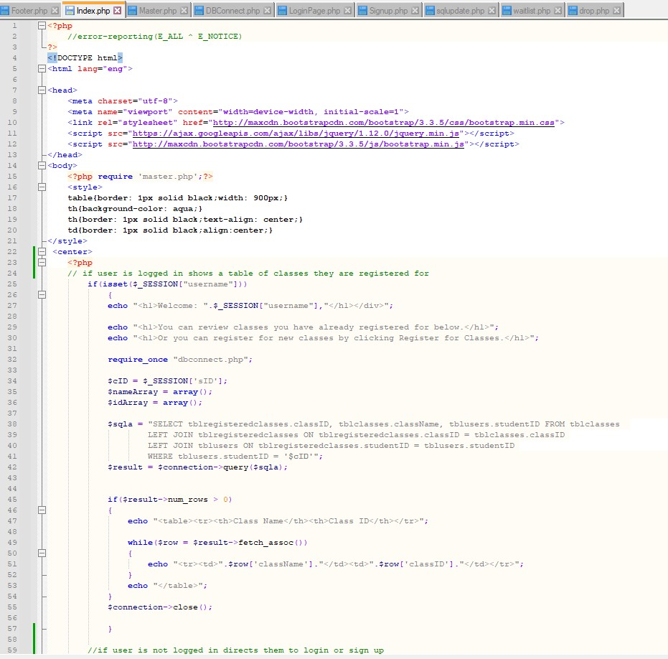

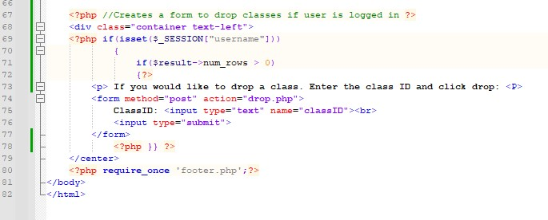

**Registration Page without semester selected**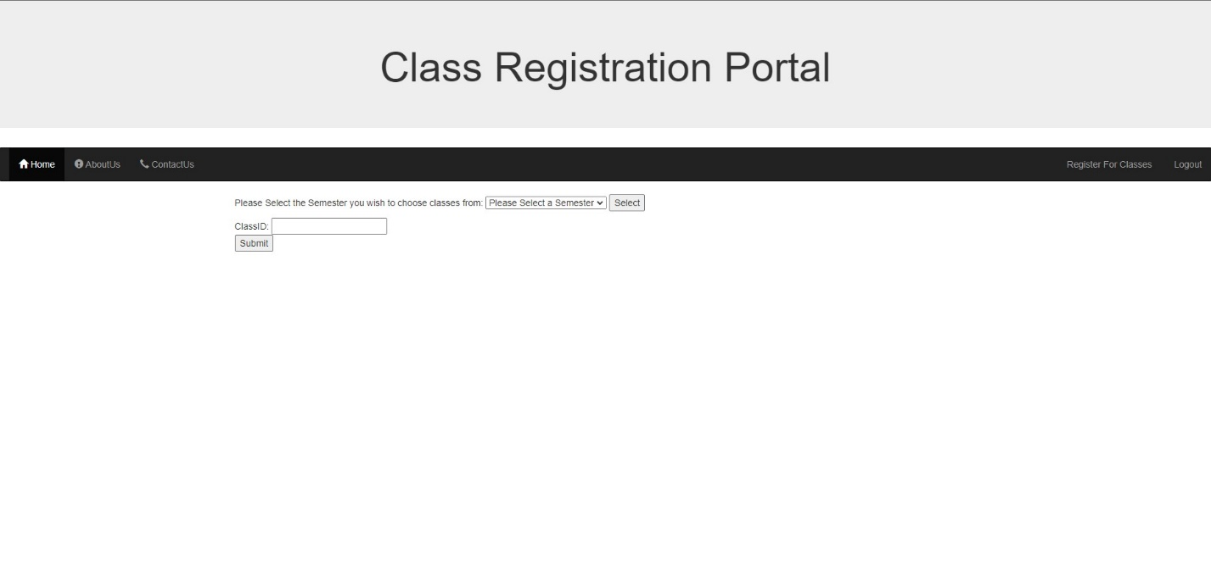

**Registration Page with semester selected**

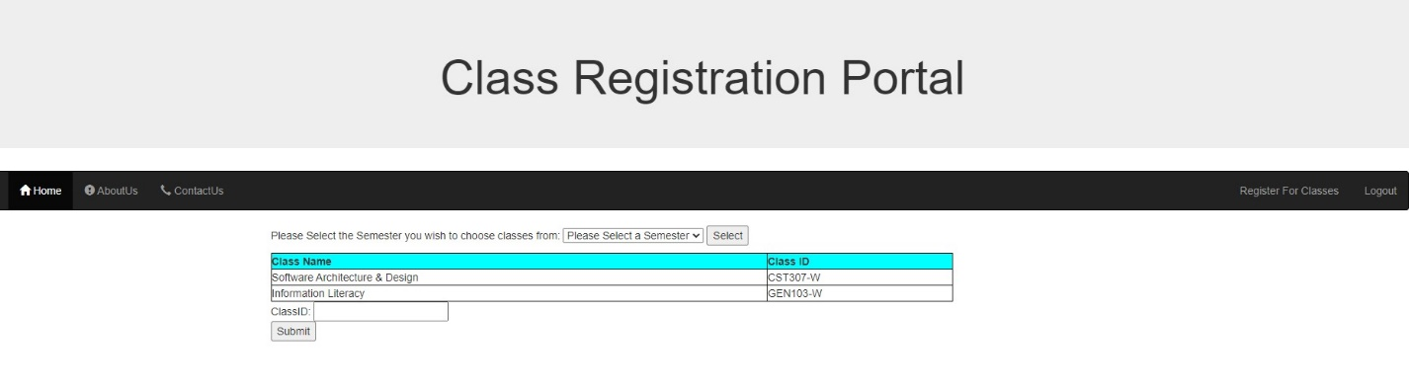

**Registration Page PHP**

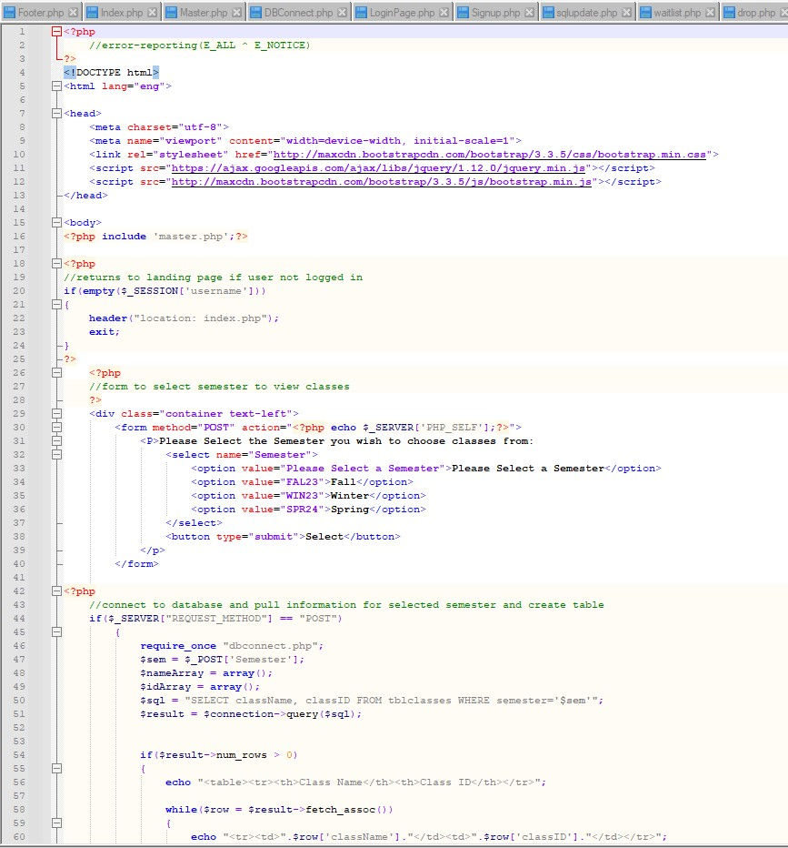

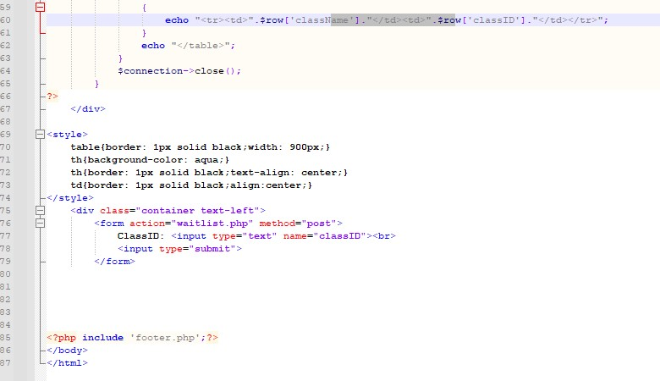

**Successful registration**

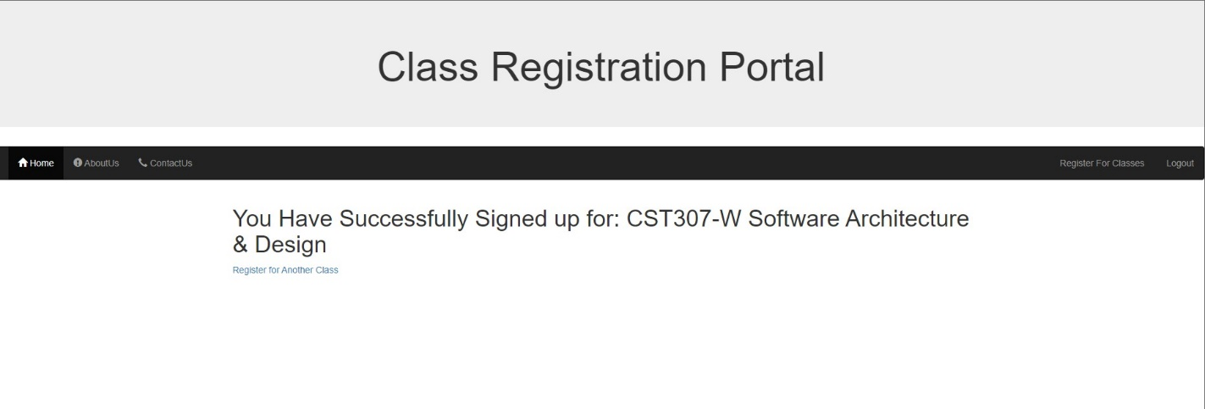

**Successful registration php**

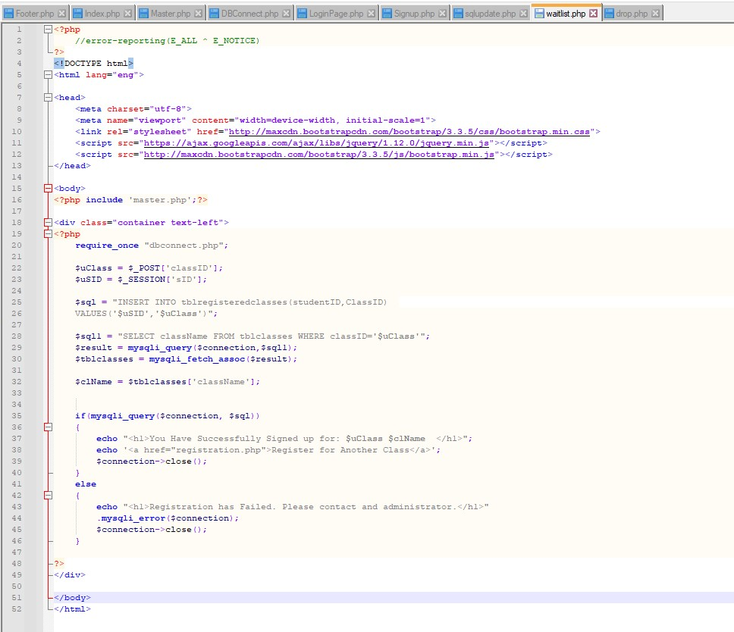

**Table for classes**

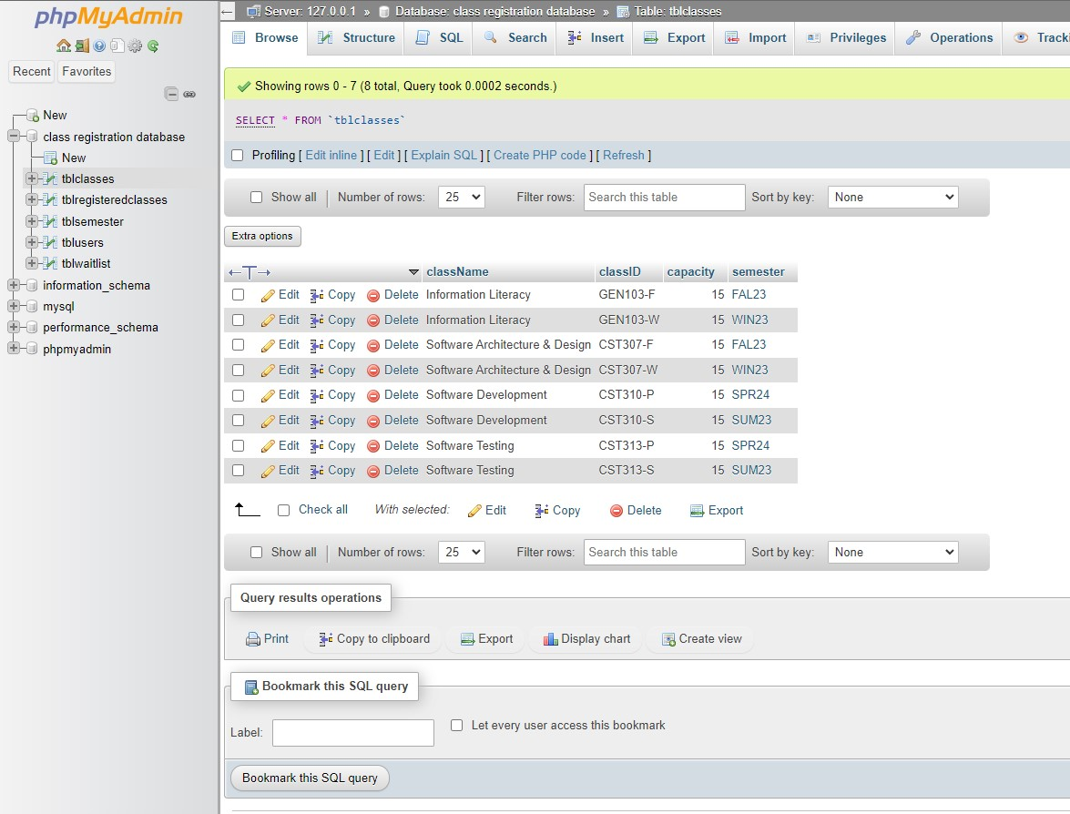

**Table for registered classes before new register**

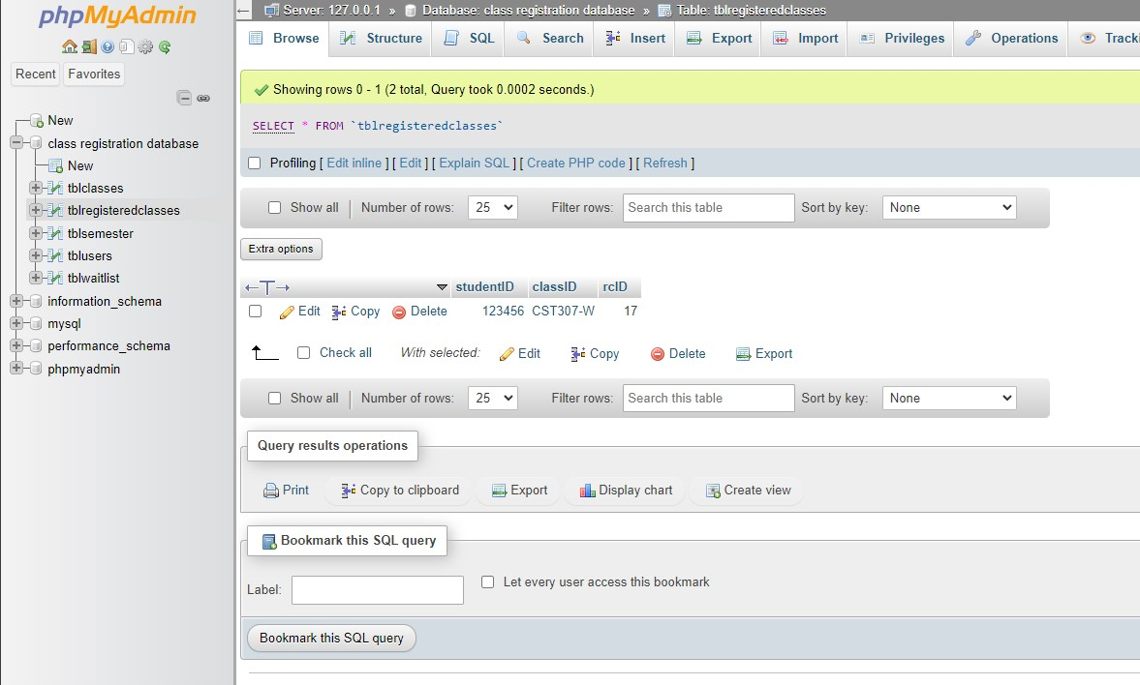

**Table for registered classes after new register**

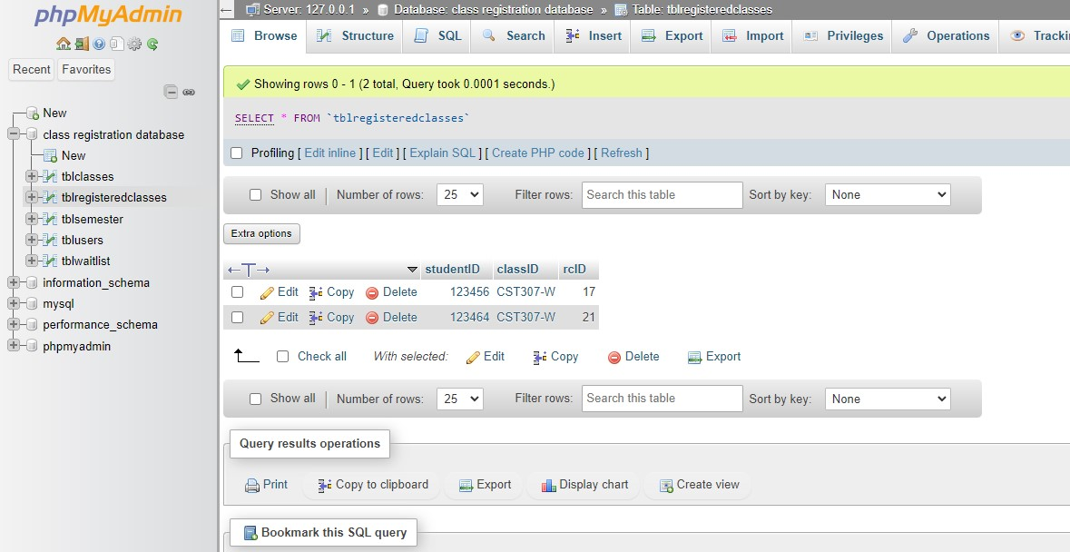

**Table for users before new user signup**

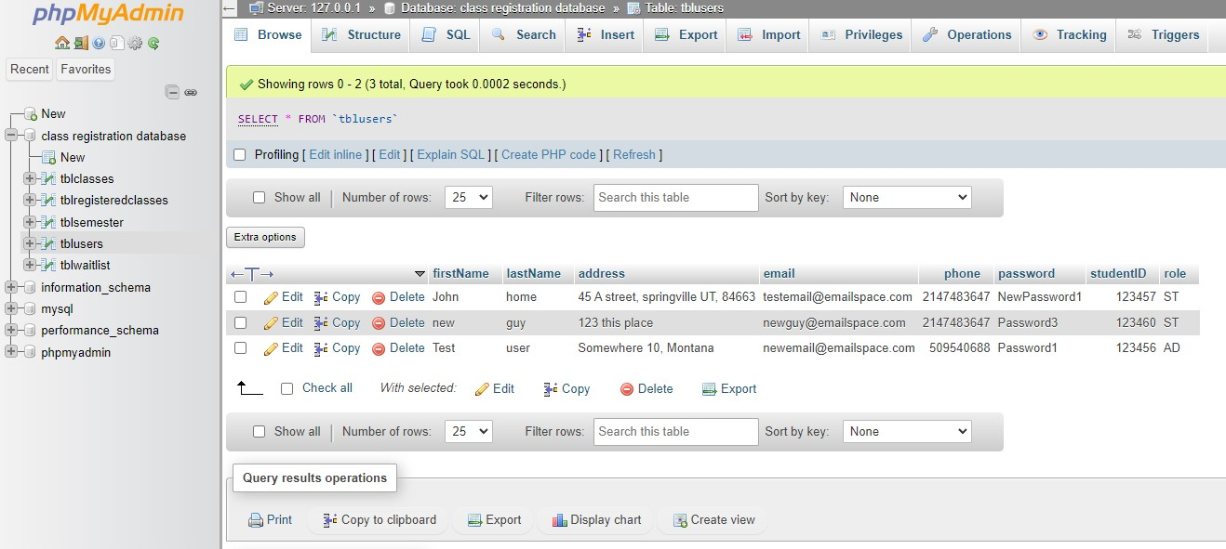

**Table for users after new user signup**

